Opt Art

Robert Bosch
Oberlin College

Optimization, the branch of mathematics concerned with optimal performance, is all about finding the best way to complete a task---creating a schedule for a tournament, matching professors with courses, constructing an itinerary for a traveling salesman. Usually, the goal is maximize profit or minimize cost.

But optimization can also be used to create pictures, portraits, and sculpture.

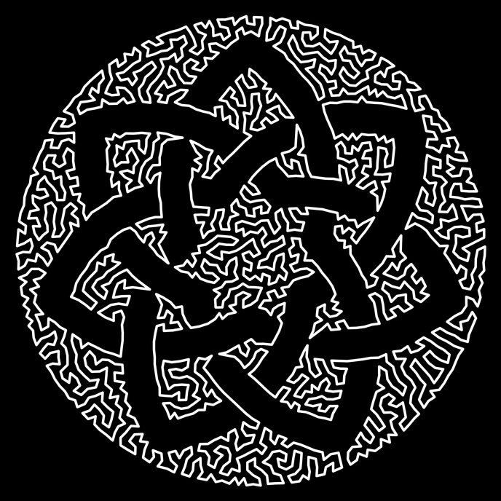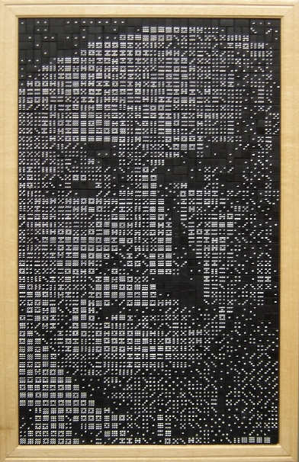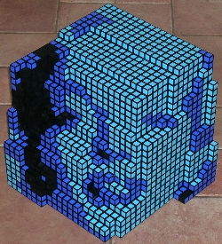

For the past five years, I have helped numerous teachers (grades 1-12) bring together Math and Art in their classrooms. (The ''For Educators'' section of my website http://www.dominoartwork.com contains detailed plans and instructions (in PDF format) for 12-set double-9-domino renderings of Dr. Martin Luther King Jr., Abraham Lincoln, the Mona Lisa, and the Statue of Liberty.) I have also sponsored several undergraduate Opt Art research projects.

In the near future, I would like to create a user-friendly version of my domino code and devise sets of activities that children could do in conjunction with the assembly of a domino portrait (or the viewing of a piece of TSP Art). I also plan on continuing my research explorations.

Selected references
R.A. Bosch, ''Constructing domino portraits,'' in Tribute to a Mathemagician, ed. B. Cipra et al., A.K. Peters, 2004, 251-256.
R. Bosch, ''Opt Art," Math Horizons 14(3) (2006) 6-9.
R. Bosch and A. Herman, ''Continuous line drawings via the traveling salesman problem,'' Operations Research Letters 32 (2004) 302-303.
R. Bosch and A. Herman, ''Pointillism via linear programming,'' The UMAP Journal 26(4) (2005) 393-400.
C.S. Kaplan and R. Bosch, ''TSP Art,'' Proceedings of Bridges 2005 (2005) 303-310.

