DRAFT #4 George W. Hart January 18, 2007

Truncated Icosahedron CD Sculpture Instructions

Materials and time required
  - 150 CDs are needed. A few might break, so have at least 160. They can be new blank CDs, or recycled (used) with mixed labels, or surplus from a printed run (all the same label). (Surplus CDs can sometimes be obtained from manufacturers, for art use, if they develop a new product version and discard their stock of the previous version.) Do not use DVDs, because they are constructed differently and are not as strong.
  - 180 cable ties are needed. When an assembly error is made or a CD is broken, some ties will be cut off to make the repair, so have 300 ties available. They should be 6 to 8 inches long.
  - A pair of diagonal wire cutters.
  - String to suspend the sculpture.
  - A place to hang it from, strong enough to support 10 pounds.
  - Plan 1.5 hour for preparation with drawing, and 1.5 hour for assembly.

- Preparation work to understand the structure, before construction.

Note: the underlined numbers in this section are the answers to fill-in-the-blank questions that can be elicited from students.

We must understand the form to build it. Visualize these forms by drawing them. Make your drawings large. It will be helpful to have first made or at least have on hand physical models of a cube, truncated cube, icosahedron, and truncated icosahedron, perhaps made of paper.
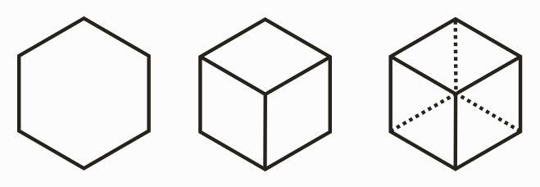
  - Here is one way to draw a cube. Draw a regular hexagon. (Note: there are two vertical sides, no horizontal sides.) Connect every second vertex to a point at the center. With dotted lines, connect the remaining three vertices to a point that is also at the center. The cube has 6 faces, 8 vertices, and 12 edges. At each vertex, 3 squares meet.
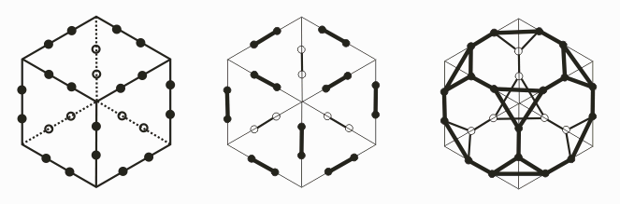
  - A truncated cube is a cube with the corners cut off. To draw it, start by drawing a cube again, but lightly, and larger. Mark two points on each of the cube’s edges. The points should divide the edges into three approximately equal pieces. Darken the middle third of each cube edge. Around each cube vertex, connect three points to make a triangle with dark lines. In the diagram above, the lines in the back are drawn lighter than the ones in the front. The truncated cube has 14 faces, 24 vertices, and 36 edges. (Don’t count one-by-one; use addition and/or multiplication.) At each vertex, 1 triangle and 2 octagons meet.

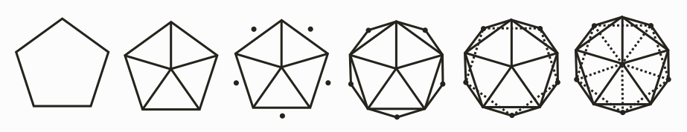
  - Here is one way to draw an icosahedron. Draw a regular pentagon—large. (Try to make it regular, with equal sides and angles. It shouldn’t look like a house.) Connect each vertex to the center. Add a dot just outside of each edge. Connect each dot to two nearby vertices of the pentagon. With dotted lines, connect the five dots in a cycle to make a dotted pentagon. With dotted lines, connect the five dots to the center. The icosahedron has 20 faces, 12 vertices, and 30 edges. (Count these using groups of five.) At each vertex, 5 triangles meet.

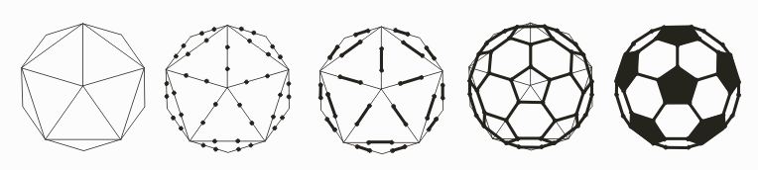
  - A truncated icosahedron is the shape of a soccer ball. Draw another icosahedron, as above but large and leave out the dotted lines. (We are leaving out the back to keep things simple.) Mark two points on each edge of your icosahedron, dividing each edge into thirds. Darken the middle section of each edge. Around each icosahedron vertex, connect the five dots with dark lines, to make a pentagon. If you want it to look more like a soccer ball, darken the pentagons. The truncated icosahedron has 12 pentagons, 20 hexagons, 32 faces, 60 vertices, and 90 edges. At each vertex, 1 pentagon and 2 hexagons meet. You’ll need to carefully keep track of your pentagons and hexagons in what follows. Remember that each vertex has the same combination: one pentagon and two hexagons.

With middle school students, stop the drawing at this point and start the assembly. With high school students, continue with the next drawing step

Foreshortening….
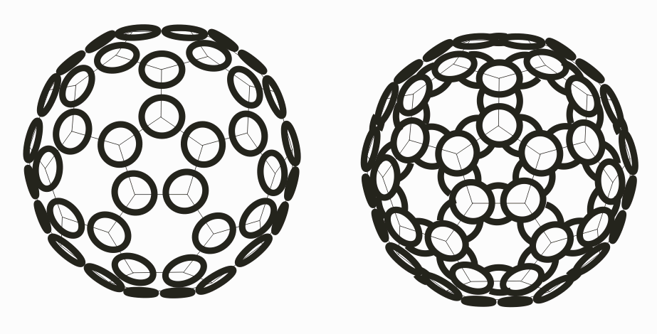
  - Our sculpture is based on the truncated icosahedron, with one disk for each vertex and one disk for each edge. The disks overlap and are connected by cable ties which are the “glue” to hold everything together. During parts of the construction below, when students are not assembling CD modules, they can work on drawing a sketch of the sculpture. First, lightly draw a truncated icosahedron either by the steps above or by tracing their first drawing. Then place a dark ellipse (representing a CD seen at an angle) over each vertex. They should just touch at their edges. Because of foreshortening, the ones near the center (which are seen face-on) appear like circles but the ones near the sides (which are seen from an angle) appear like ellipses. Draw the CDs with more foreshortening as they get further from the center. Then indicate a CD for each edge with two arcs that represent an “edge disk” behind the “vertex disks”.
  - Including edge disks and vertex disks, we’ll need a total of 150 CDs. Wherever an edge disk overlaps a neighboring vertex disk, they will be tied together with a plastic cable tie that goes through the center hole of each. We’ll need 180 cable ties.

- Assembly Process

Care is required. CDs are made of acrylic plastic, which is strong (the windows in storm doors are made of acrylic) but brittle. If bent too much, they crack and snap. One must be careful during the construction not to over-bend the CDs. If the sphere is rested on a table, the lower CDs will be bent from the weight above and will likely snap. So the sculpture must always be suspended, as described below, so that its weight does not bend the CDs. (If one makes a circular “nest” from a blanket, the sculpture can be rested so the nest holds the weight without the CDs bending.)

If a CD does snap, the sculpture can be repaired. The ties can be cut with wire cutters. The broken CD is easily removed and a replacement added. Similarly, when a mistake in assembly is made, you can cut the ties necessary to correct it.

Caution the class not to play with the cable ties:
“Do not tie them around your fingers or wrists.”

Demonstrate how the tip goes into just one side of the locking part of the tie, not the other side. Tell them that when they use a tie wrap to connect two CDs, the locking part of the tie wrap should end up at a CD hole and the tie should be pulled tight.

The vertex disks will be on the outside of the sphere, with their shiny side facing outwards. The edge disks will be on the inside, with their shiny side facing inwards. This means that whenever two CDs touch, they touch label-to-label. The shiny sides do not touch other CDs.

We will make twelve pentagon modules, working in groups, and then connect them. If the class is divided into six groups, each group makes two modules.

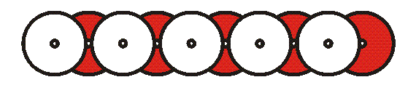
- Here is how to make one module. On a flat table, make a “chain” of ten CDs, as above. The shaded parts of the image represent the printed labels of the CD. The five CDs on the bottom have their shiny side down. The five on top have their shiny side up. From disk to disk, the connection is made with a cable tie through two CD holes. You can position each tie so the free end sticks up out of the plane at either of the two center holes that the tie passes through. The free ends will naturally point upwards. Pull all ties tight. You still have enough freedom to adjust the angle between disks.
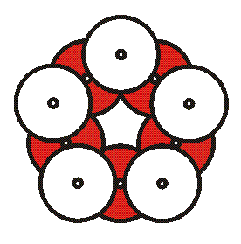
- Curve the chain into a cycle and close the loop with one additional tie. This makes a regular pentagon as shown above.
- Choose one pentagon module to be at the “North Pole”. Place it on a flat table to be used for the construction. The other modules will be added to it.

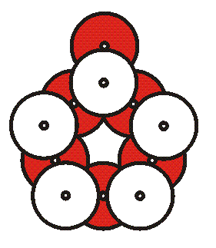
- Have five of the groups add an additional facedown CD to the bottom of their pentagon, making the shape above. Call this extra CD an “ear”. The ear will be the connector that joins their module to the center module.

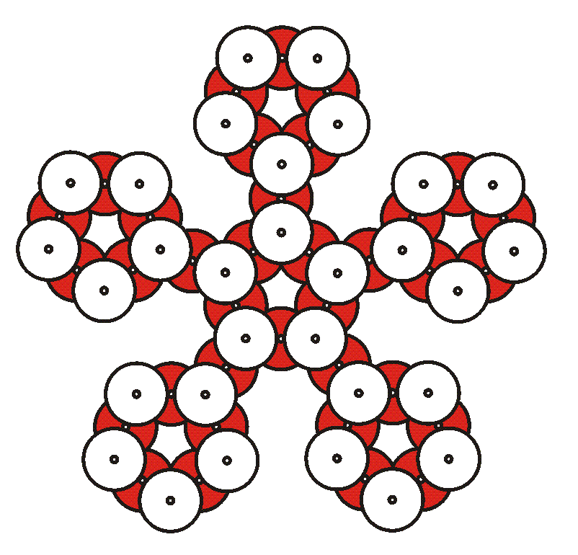
- Five one-eared modules will connect to the center module to make the shape above. One at a time, connect a module, by their ear, to the bottom of a CD of the center pentagon. The angles are adjustable. For now, the angles need only be approximate. We will fine-tune the angles later.

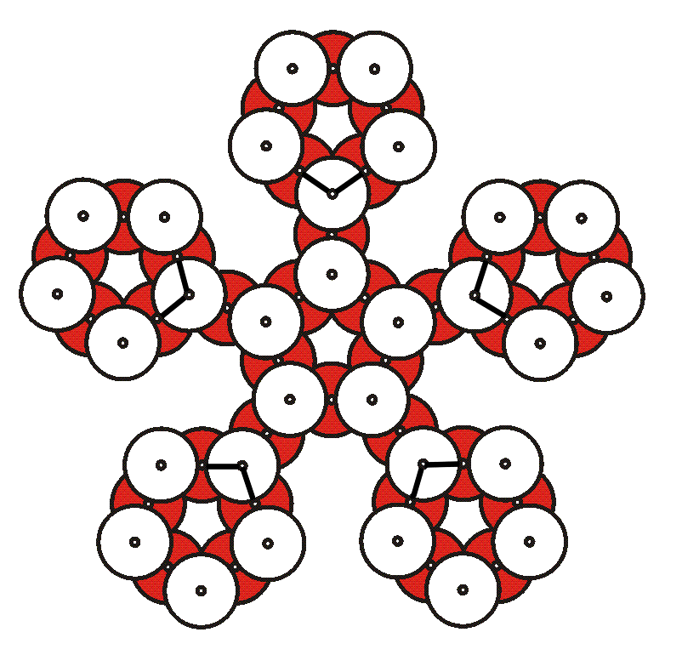
- Before adding more CDs, we will need to go from 2D to 3D. Five strings will connect to five location marked in the above figure. Each marked location is two cable ties. Tie one string through (under) both of the cable ties, so the load is distributed twice as much. The easiest way to do this is to first cut five pieces of string each three feet long. Tie them all with a combined knot at one end. Someone can hold the knot end in the air over the center of the structure while the five loose ends are tied to the five support locations. The knots should be made the same distance (say, two inches) from the free end on each of the five strings, so the load is balanced. Remember that each string goes through the two cable ties that are part of a pentagon, to distribute the load as much as possible. Gently raise the sculpture by the strings and secure it to the ceiling. It will naturally curve to form a partial sphere. Don’t be afraid to bend the CDs slightly.

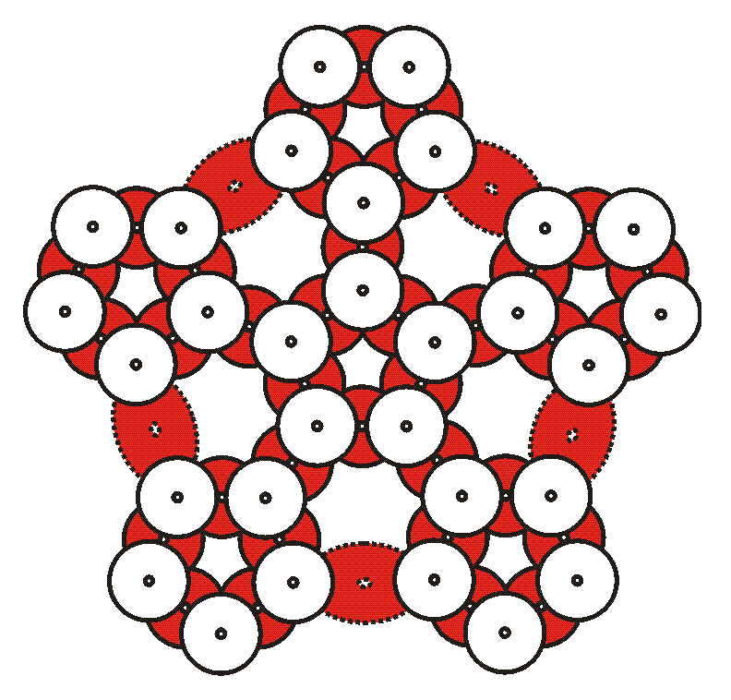
- Add the five CDs that are shown above with dotted lines. Bend things gently to make the connections. They connect the five one-eared modules to each other. Notice that they complete five hexagonal openings. This completes the top half of the sphere.
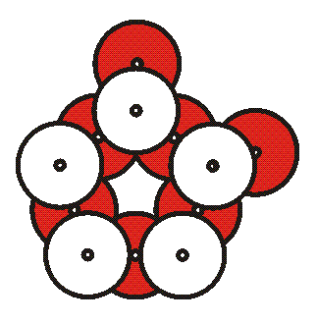
- Add two CDs shiny side down to the bottoms of five of the remaining modules. This makes two-eared pentagons, as shown above. The two ears go underneath two adjacent face-up CDs.

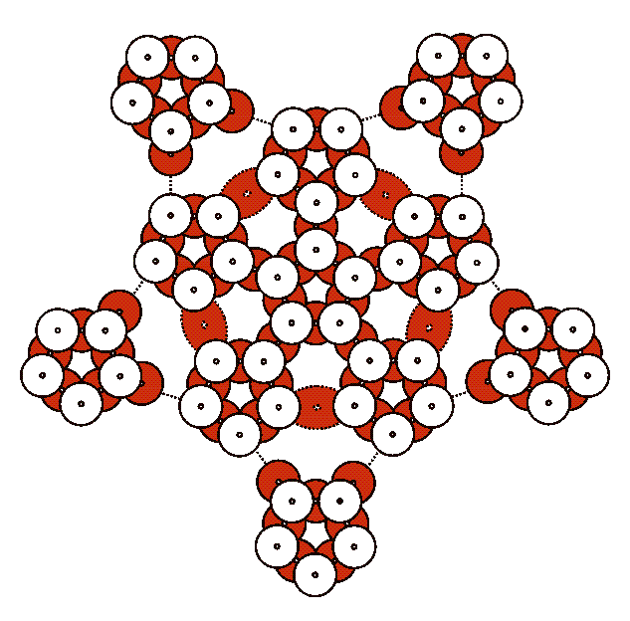
- One at a time, connect the five two-eared modules as illustrated by the dotted lines above. These will form the bottom of the sphere. Again, as you connect the modules, bend the CDs gently. You are creating more hexagonal openings.

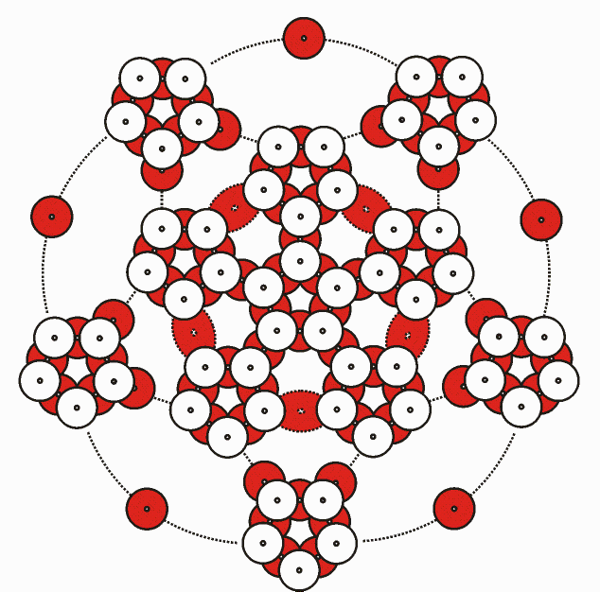
- Add five CDs that connect module-to-module, as indicated by the dotted lines above. Again, you are making hexagonal openings. As you add these, you will gently bend the modules inwards, towards the south pole.
- Add five ears shiny side down to the bottom of the remaining (twelfth) module. And insert it in the bottom of the sculpture. Connect one tie at a time, gently curving the CDs as necessary.
- When complete, you can adjust the angles to regularize all the polygons. Make sure that each set of two ties that correspond to one truncated icosahedron edge line up in a straight line.
- You can snip off all the cable tie ends if you do not like the “hairy” look.

Possible Further Explorations

Coloring Variations. With different colors of tie wraps, you can give a color to the edges, for example emphasizing the pentagons with a different color from the connecting edges.

Long-edge Variation. Make pentagon modules as above, but connect them to each other with “ears” that are not just one CD but are three CDs long. Gravity will stretch the final sculpture into an egg shape. But if you spin it, it widens.

Tall Variation. An icosahedron can be seen as a pentagonal antiprism capped by two pentagonal pyramids. An elongated structure can be made as a stack of two or three pentagonal antiprisms, capped by two pyramids. Truncate such a structure to make a prolate form composed of pentagons and hexagons. You can make a Hamiltonian cycle on this form also.

Hamiltonian Cycle Variation. With 60 strips of masking tape (or strips cut from “post-its”) mark the edges of a Hamiltonian cycle on your truncated icosahedron. One at a time, replace the remaining ties with a different color. Exercises on paper with nets of polyhedra may be done first, to explain the concept of a Hamiltonian cycle.

